**Output only**

**School Summary**[**¶**](http://localhost:8888/notebooks/Homework/pandas-challenge/PyCitySchools/PyCitySchoolsmain.ipynb#School-Summary)

* Create an overview table that summarizes key metrics about each school, including:
  + School Name
  + School Type
  + Total Students
  + Total School Budget
  + Per Student Budget
  + Average Math Score
  + Average Reading Score
  + % Passing Math
  + % Passing Reading
  + % Overall Passing (The percentage of students that passed math **and** reading.)
* Create a dataframe to hold the above results

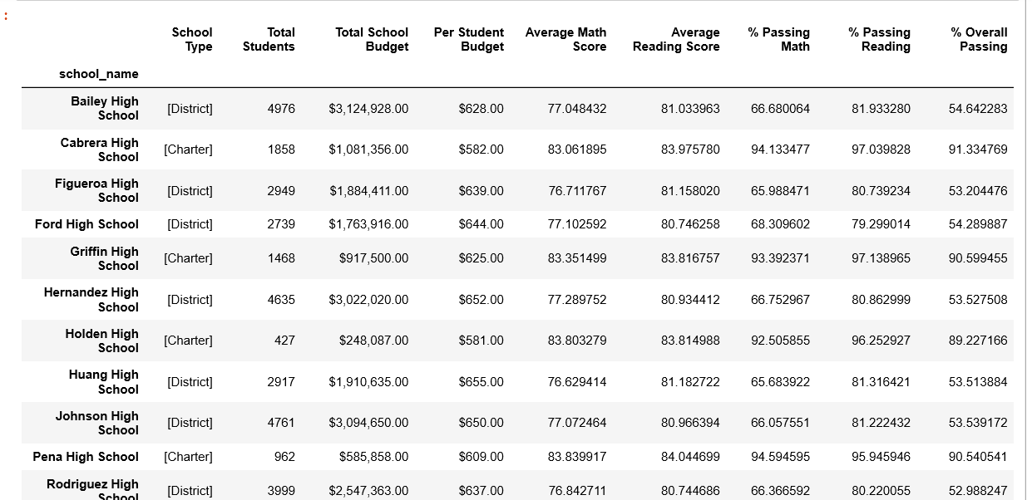

## Top Performing Schools (By % Overall Passing)[¶](http://localhost:8888/notebooks/Homework/pandas-challenge/PyCitySchools/PyCitySchoolsmain.ipynb#Top-Performing-Schools-(By-%-Overall-Passing))

* Sort and display the top five performing schools by % overall passing.

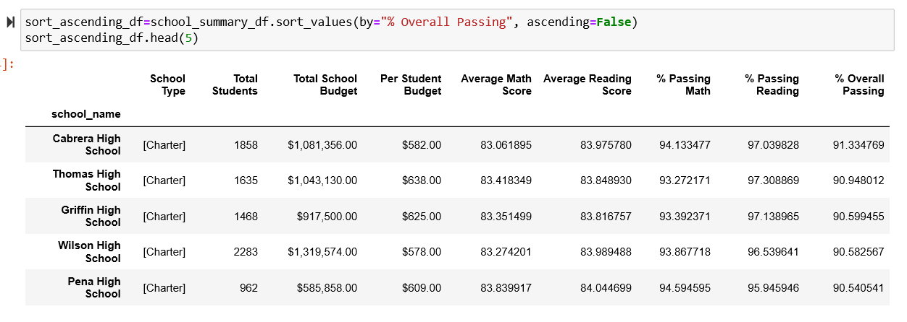

## Bottom Performing Schools (By % Overall Passing)[¶](http://localhost:8888/notebooks/Homework/pandas-challenge/PyCitySchools/PyCitySchoolsmain.ipynb#Bottom-Performing-Schools-(By-%-Overall-Passing))

* Sort and display the five worst-performing schools by % overall passing.

